June 2012 Thank you so much for your continuing support.
What is Spring
Of Hope?

Spring of Hope (SoH) aims to assist children with disabilities and their families in rural Uganda. Working in the Kayunga and Mukono districts of Uganda SOH’s aims to:
- Enable children with disabilities to reach their fullest potential.
- Change attitudes so children with disabilities are fully accepted in their community.

Spring of Hope Uganda is a community based rehabilitation (CBO) programme and has been working in Uganda since August 2004 formerly a YWAM (Youth with a Mission) project.

Spring of Hope Trust, based in the UK, fundraises for this important work. Both organisations were registered in August 2011 so programmes can grow and develop.

For more information:

Website:
www.springofhope.org.uk.com

Uganda Contact:
Teresha & Israel Karahukayo:
Spring of Hope Uganda
PO BOX 1153
JINJA
UGANDA
EAST AFRICA
springofhopeug@gmail.com
UK Contact:
Jean Clark
01480 890033
springofhopeuk@talktalk.net

SoH Trust Website: http://www.springofhope.org.uk/sohtrust.html

Spring of Hope Blog:
http://springofhopeuganda.
blogspot.com
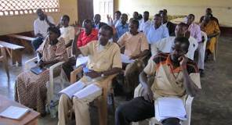
Great News: One new activity has been training community leaders and key members of the community. We still see negative views towards those with a disability. Often doors are shut in Ugandan society for people with disabilities. Our heart is to see children and people with disabilities have access to all areas of community life. So in January we hosted sensitisation meetings for Kangulumira local leaders. We have felt a burden to train the church leaders on how to reach out and support people with disabilities. So far we have hosted three seminars for pastors to teach them what disability is, the truth of what causes a disability, what role the church has in reaching out to people with disabilities, and ways the church can reach out to include people with disabilities in the church. We also shared that God made people with disabilities in his image and that people with disabilities are people first.
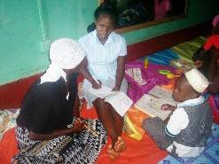
Over the last few years we have been receiving occupational therapy students from across the globe. Here in Uganda we have the privilege of receiving 2nd and 3rd year occupational therapy students from Mulago School of Occupational Therapy. Prosy and Cathy are two of our most recent students, with us in April and May. Prosy said, “ I am currently on field placement for 2 months. As an occupational therapy student I’ve been carrying out different activities which have assisted me in completing my studies. I am a 3rd year student and working in SOHUG has been my last placement. I enjoyed my time with SOHUG immensly.”
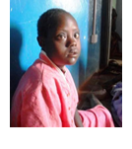
One of our Children is Nayiima. We met her and her mom at a Parish Clinics. They had never received help before. Nayiima has a lot of potential, but hasn’t had the opportunities. They’ve started coming to drop-in clinics. Her mother was so encouraged she’s decided to enrol Nayiima in school. Mama Nayiima lives alone with very little money to supports herself and her children but the school’s assisted with a reduced rate but Nayiima is still in need of a sponsor. Please contact us if you would like to support Nayiima or one of our other children.
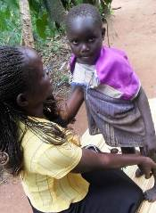
Our new Occupational Therapist! Barbara Nattabi has started and is using her great skills. We were sad to see our old OT go and wish him the best. We are truly excited to see the talents and enthusiasm that Barbara brings to the team. A word from Barbara- I am a qualified occupational therapist. I am Muganda (tribe) from Luweero district. I enjoy listening to gospel music and cooking. I have been working with SOHUG for the last two months and it is a great place to work! I very much enjoy working in the community, as each day is different. I carry out assessments in the community, make home visits and follow up programs for clients who need therapy, teach activities of daily living (especially work and self-care), prescribe special equipment, teach vocational skills, supervise OT students and interns and counsel clients and their families.
What SoHUG Does
The Ugandan based team provides:
- Assessment and Drop-In Clinics
- Home visits
- Adaptive equipment.
- Access to corrective surgery
- Nutrition programme
- Daily living skills
- Education classes
- School sponsorship and support to schools
- Free Epilepsy medication
- Sign language workshops (guardians & teachers)
- Income generating projects

SOHUG also educates the community in: causes of disability, ways to minimize risk of new disability and value of people with disabilities.

How to support SoHUG:

Financially online:
www.sohug.givengain.org
UK Tax payers via CAF www.cafonline.org
or Stewardship (UK) www.stewardship.org.uk
Account No 20041306

Volunteer Opportunities

In Uganda (see website)

or Raising funds where you live.
(ex. coffee morning, table top sale or run a sponsored event)

- Prayer support.

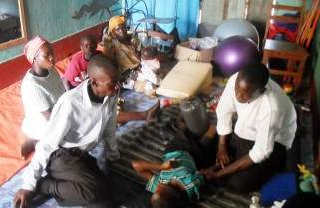
Drop-in Clinics run on Thursdays, starting at 10am often going on until 4pm depending on numbers generally over 20 children each week. Parents bring their children for treatment from the physiotherapist or occupational therapist. The children’s ages range from babies to school-age children. The disability type varies and includes those with Hydrocephalus and Cerebral Palsy. Each child receives an individualized therapy program and progresses at their own rate. Some children cry and scream the whole time even though they are not in any pain, while others laugh and giggle when bounced on the balls. Therapy is given in a fun way; toys are used to distract and motivate children as therapists manipulate and stretch joints in the position that is most beneficial for the child. It is also a time for parents to learn and develop their skills as they watch attentively and therapists provide suggestions for exercises to work on at home. We’ve seen huge improvements in condition, mobility and overall attitude.

Expected Soon We are excitedly awaiting the newest member of our SOHUG family: Baby “Wise” Karahukayo is due to be born later this month will be the first child born to Israel and Teresha Karahukayo (Directors).

Every Little Helps: We just want to say thank you to all of you who kindly give to SoH. We really appreciate every sacrifice you make for the children with disabilities here in Uganda. The projects and initiatives run on donations from people like you. For anyone interested in giving, please contact us directly or go to our website to give (see more details in the right column)

Thank you again for all your support
from everyone at Spring of Hope.

